**Name: Sainyam Agrawal**

**Reg No: 20BCY10151**

**Assignment: Bash Shell Basics**

**Task 1: File and Directory Manipulation**

1. Create a directory called "my_directory".

1. Navigate into the "my_directory".

1. Create an empty file called "my_file.txt".

1. List all the files and directories in the current directory.

1. Rename "my_file.txt" to "new_file.txt".

1. Display the content of "new_file.txt" using a pager tool of your choice.

1. Append the text "Hello, World!" to "new_file.txt".

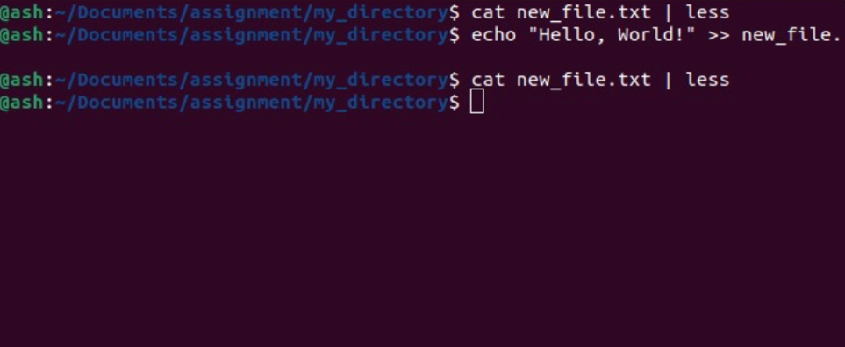

1. Create a new directory called "backup" within "my_directory".

1. Move "new_file.txt" to the "backup" directory. A screenshot of a computer

   Description automatically generated with medium confidenceA picture containing text, screenshot, purple, violet

   Description automatically generated
2. Verify that "new_file.txt" is now located in the "backup" directory.

1. Delete the "backup" directory and all its contents.

**Task 2: Permissions and Scripting**

* Create a new file called "my_script.sh".

* Edit "my_script.sh" using a text editor of your choice and add the following lines:

**bash**

**#!/bin/bash**

**echo "Welcome to my script!"**

**echo "Today's date is $(date)."**

**Save and exit the file.**

* Make "my_script.sh" executable.

* A picture containing text, screenshot, violet

  Description automatically generated
* Run "my_script.sh" and verify that the output matches the expected result.

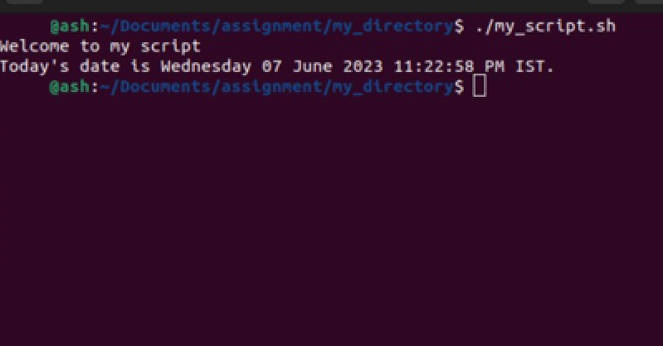

**Task 3: Command Execution and Pipelines**

* List all the processes running on your system using the "ps" command.

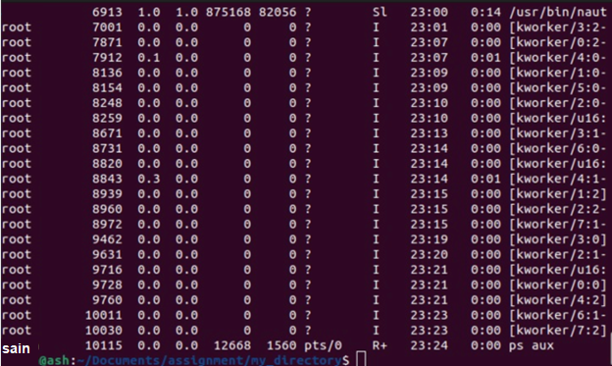

* Use the "grep" command to filter the processes list and display only the processes with "bash" in their name.

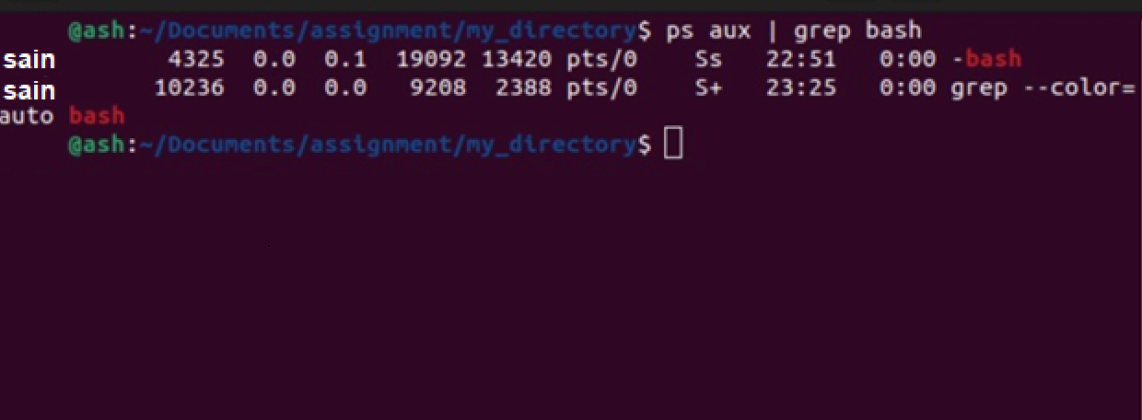

* Use the "wc" command to count the number of lines in the filtered output.

**Explanation of the commands:**

The ps aux command lists all the running processes on the system.

The | (pipe) symbol takes the output of the previous command and passes it as input to the next command.

The grep command is used to search for a specific pattern or text in the input.

In this case, grep bash filters the processes list and displays only the lines that contain the word "bash".

Finally, the wc -l command counts the number of lines in the filtered output and displays the result.

By combining these commands with the pipe operator, you can filter and process the output of one command using another command.